1. Install nginx and run nginx on port number 81.

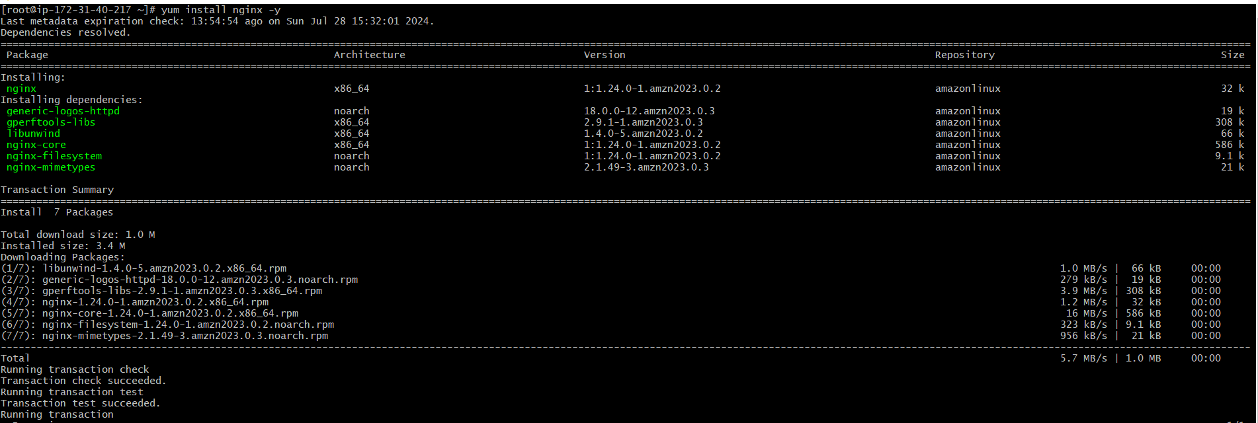



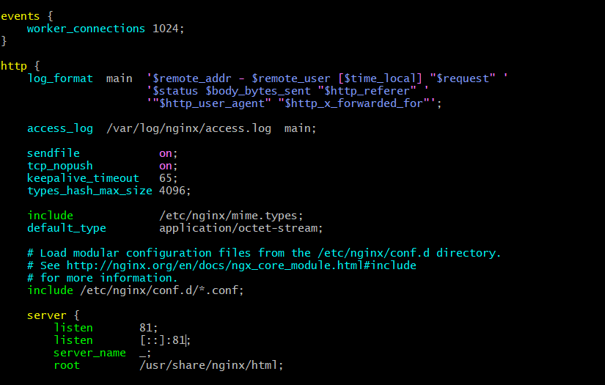



1. Deploy a sample index.html file on nginx.

1. Install Apache and run Apache on port number 82

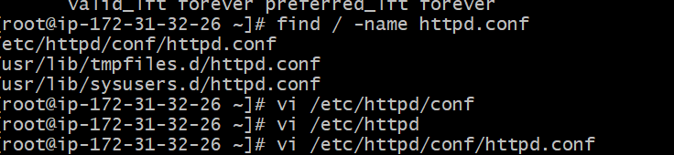

1. Deploy a sample index.html file on Apache.

1. Install Apache tomcat on port number 8082

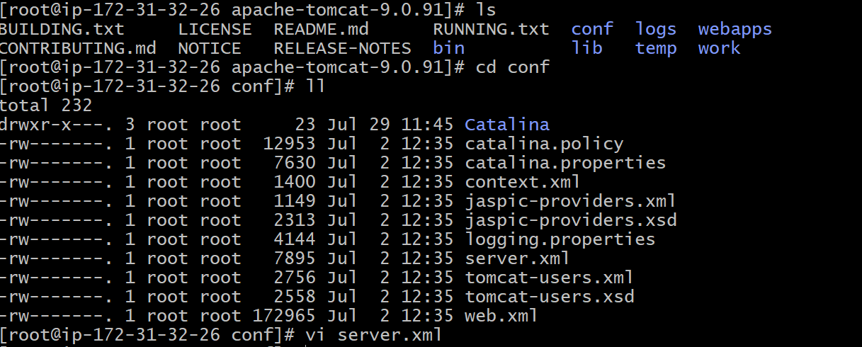

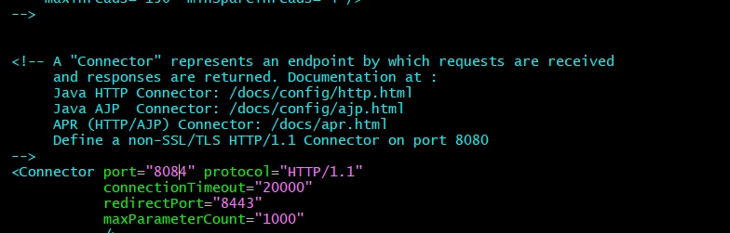

1. Deploy a sample app on webapps

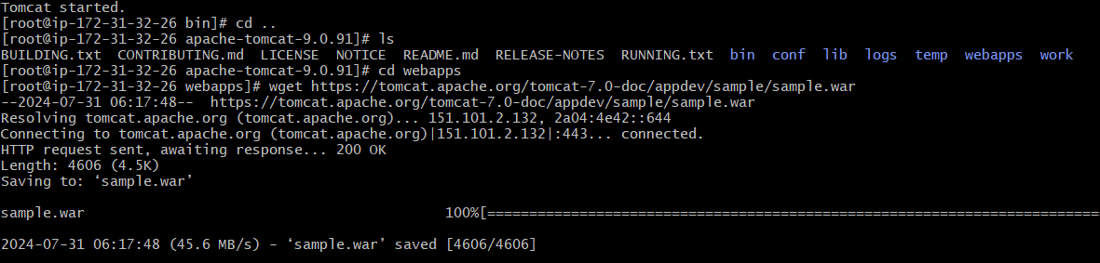

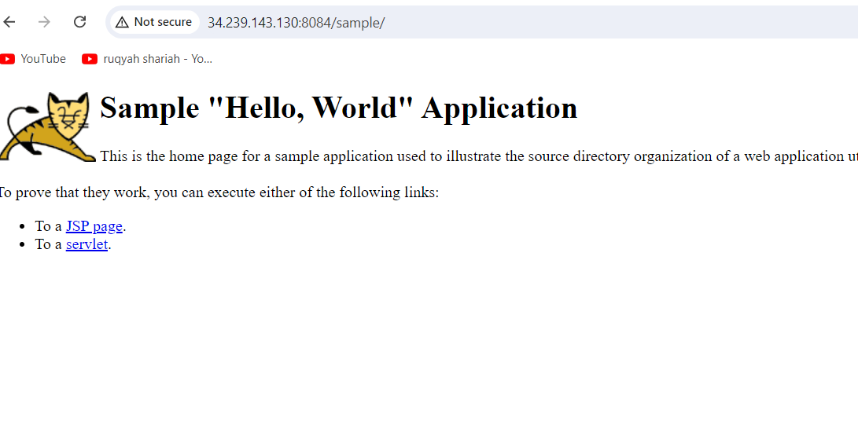

1. Create a tomcat.service file for tomcat.
2. Configure HA Proxy server

Configure HA Proxy Server:  
Launch 3 ec2 instances name as Server1, Server-2, HA-Proxy-Server.  
Server-1 Steps:

ssh -i your-key.pem ec2-user@Pubipaddress of Server-1 instance

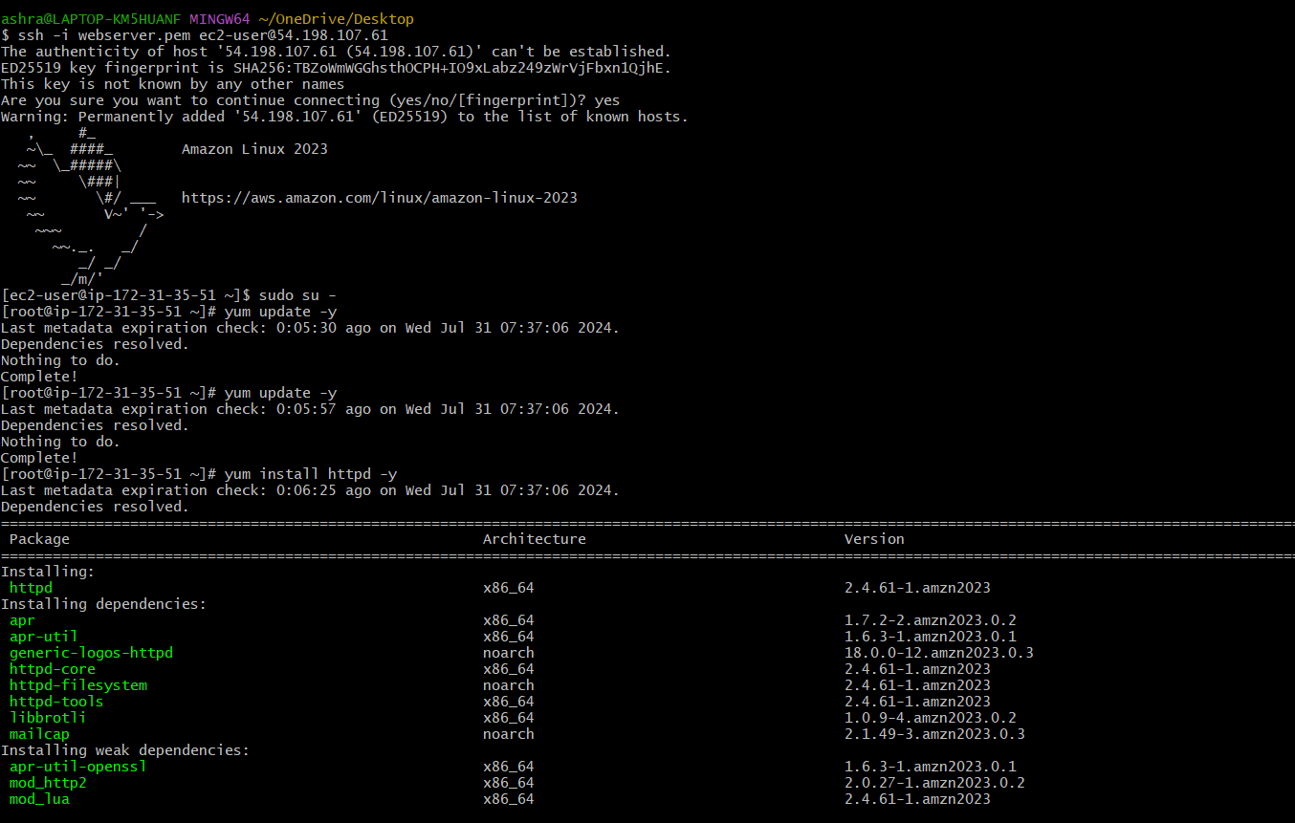

Server-2 Steps:  
Run following command to Access Server-2  
•ssh -i your-key.pem ec2-user@Pubipaddress of Server-2 instance  
•sudo -i  
•yum update -y

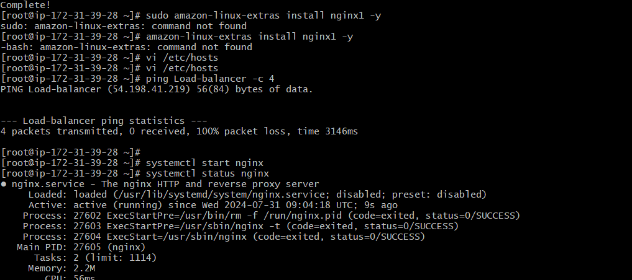

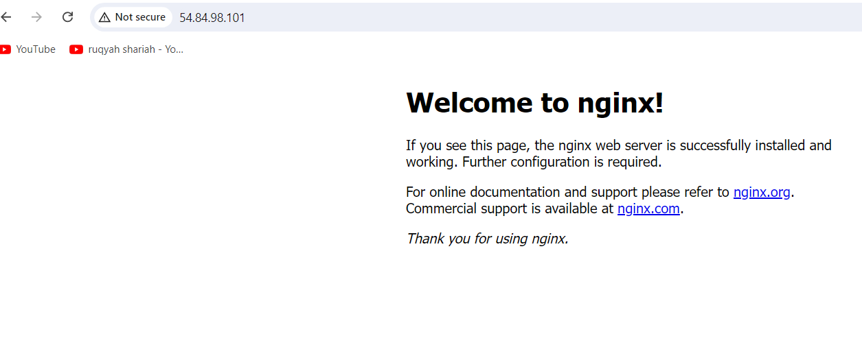

HA-Proxy-Server Steps:  
Run following command to Access HA-Proy-Server  
•ssh -i your-key.pem ec2-user@Pubipaddress of HA-Proxy-Server instance



